**Swing GUI**

1.

**GUI displays the details of each employee stored in the database**



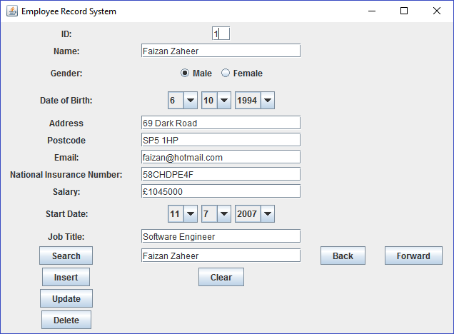 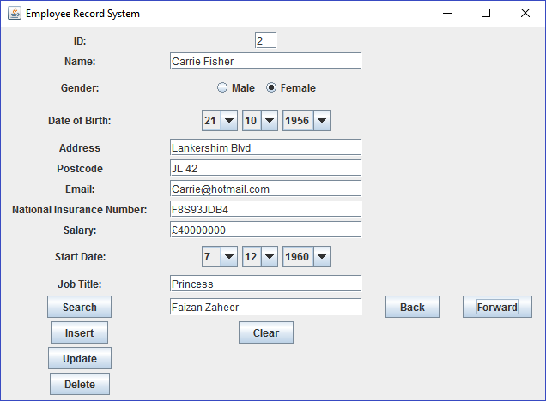 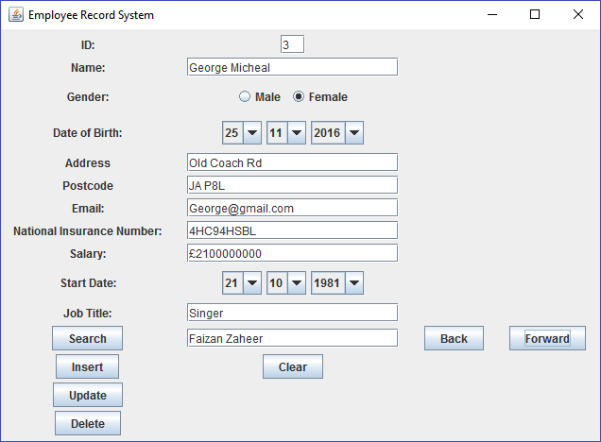

2.

**GUI has navigation buttons to allow a user to cycle through employee records both forwards and backwards individually**

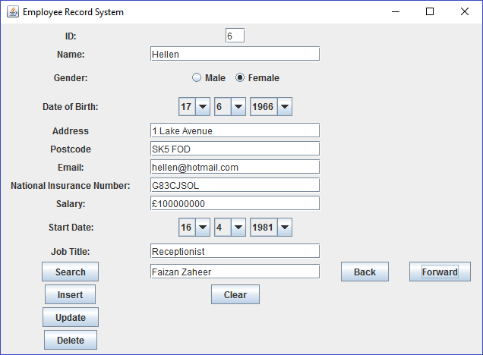 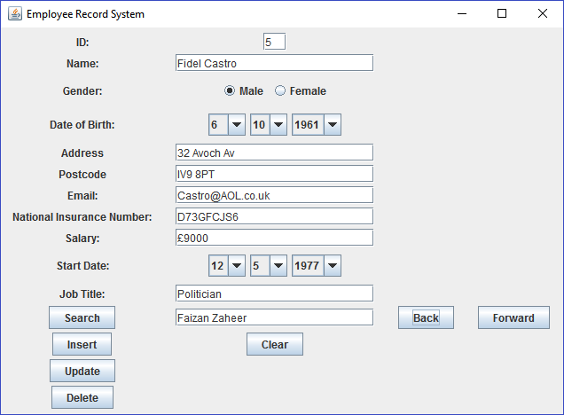

Back and Forward buttons being tested, notice how the Text Fields, Gender and Date panel adjust accordingly.

3.

**Swing GUI is fully functioning and allows employee details to be entered into the database and updated**

**Insert**

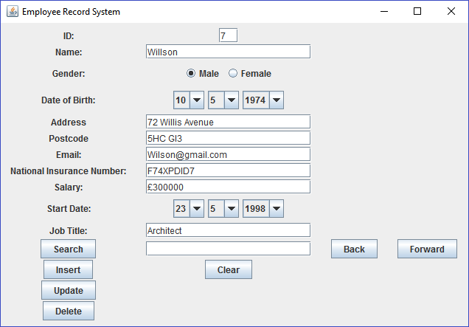



Inert Button being tested, notice the Gender and Date panels create a string in the database that corresponds with the values that have been set.

**Update**



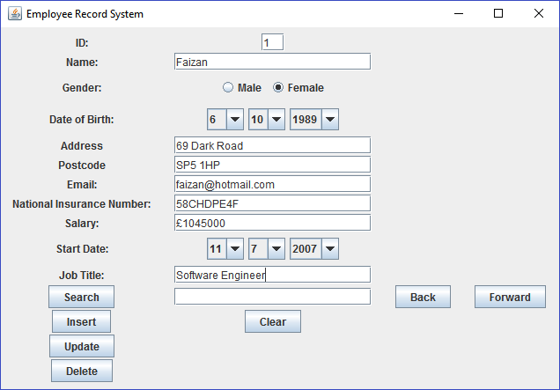

Testing the update button by adjusting some of the values, notice the Gender field and Date.



**Delete**

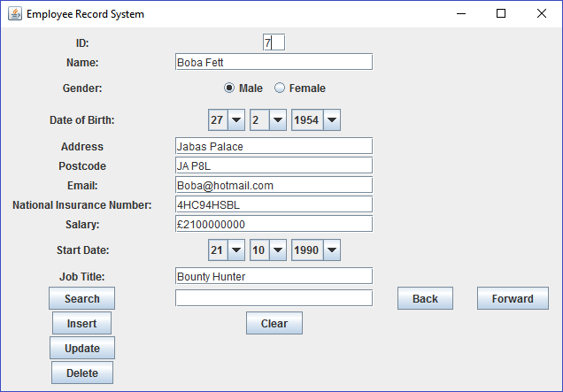

Testing the delete button by only adjusting the ID Text Field.



In this case ID number 7 is ‘Wilson’



He has been deleted.

**Advanced Features**

**The Swing GUI incorporates a fully functioning search feature**

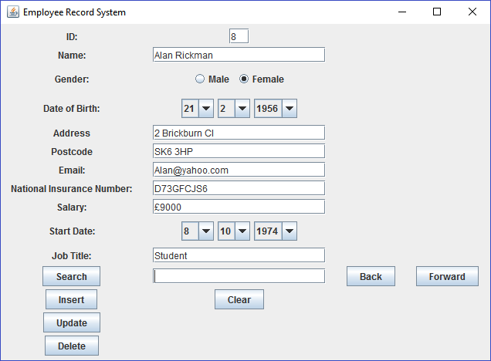 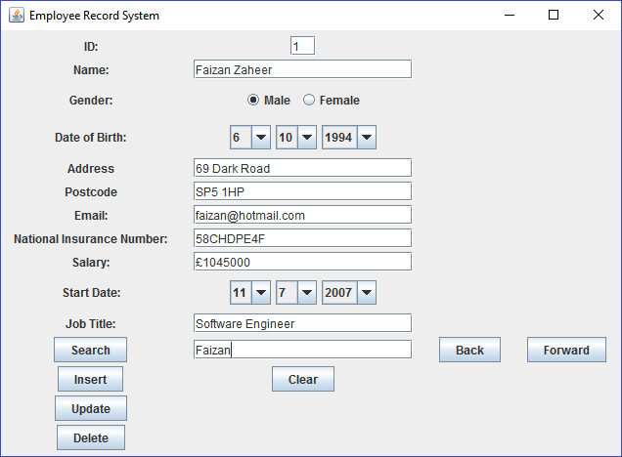

**Clear & Insert Validation**

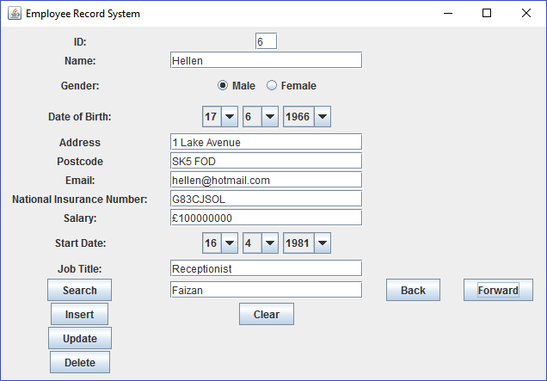

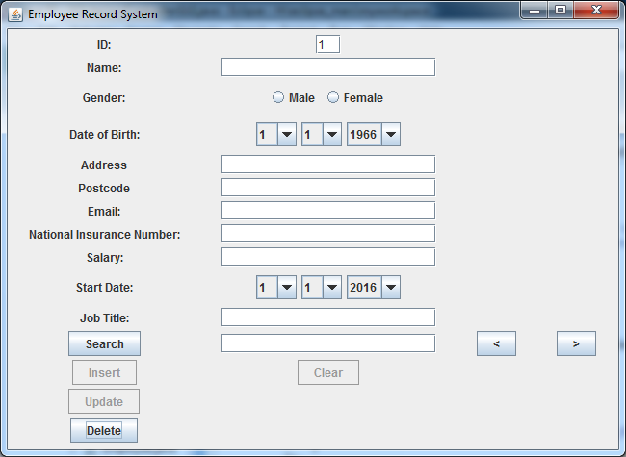

Testing the clear button, the button clears all the field and also has some validation on the insert and update buttons as well as the validation for my inert and update doesn’t allow the user to insert or update somebody in the database without a ‘Name’, ‘Postcode’ and ‘Email’.

**Date of Birth Validation JOptionPane**

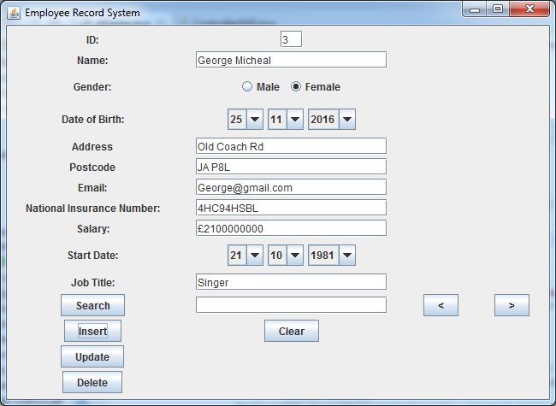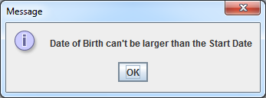

Here we are testing the Date of birth validation, as you can see this employee’s date of birth is larger than the start date, if we press insert or update a JOptionPane will appear warning the user the error they have made.

**Validation Gender**

When the user has cleared all of the fields everything will be cleared including the Gender panel, they can regain the option to insert and update by filling in the Name, Postcode, and Email Fields

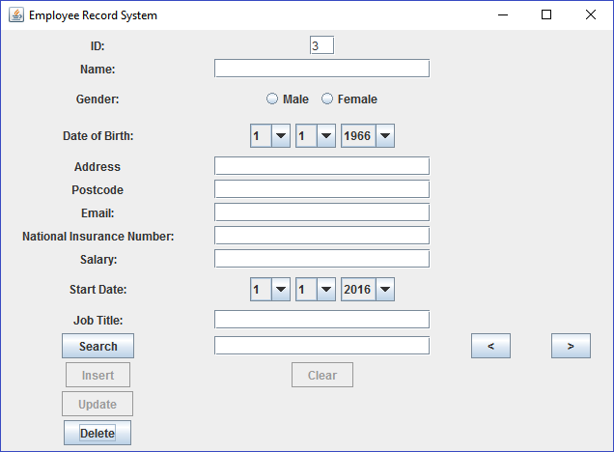

Here you can see that the insert and update button can now function but there is still no value within the gender panel

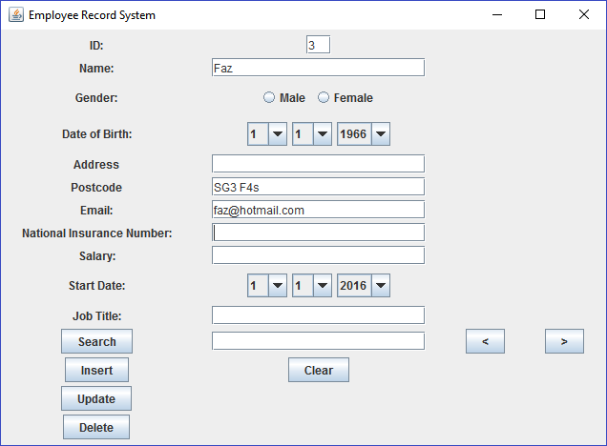

But after trying to press insert or update there will be an option panel warning the user of their mistake

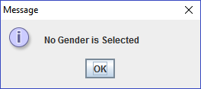

**Validation Delete**

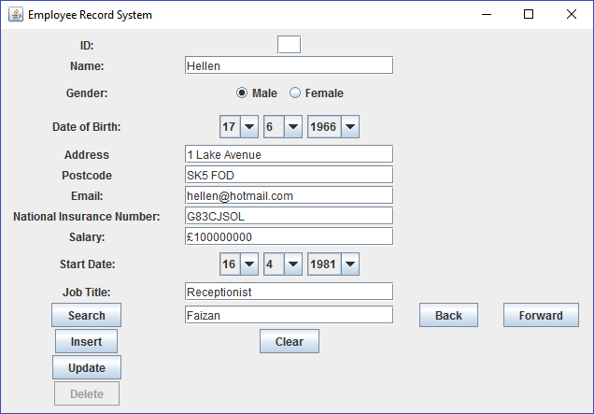

Validation on the delete button to not allow users to delete a user without a value in the ‘ID’ field.